Rajiv Dialani

CS-330

September 9, 2023

**Module 2: Project Proposal**

I chose four random objects I found around my bedroom that I can replicate using different primitive shapes. The objects are a scented candle, a circular bottle of cologne, a speaker, and a keyboard wrist rest. The objects are on top of a table mat, which is on top of a table.

Blue table mat
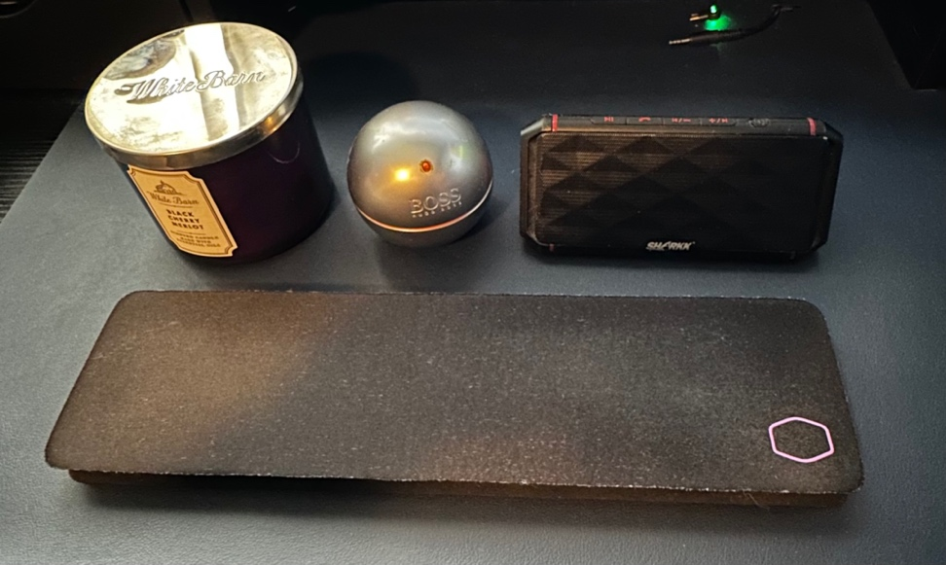

Blue Table Mat Scented Candle, Cologne Bottle, Speakers,

Keyboard Wrist Rest

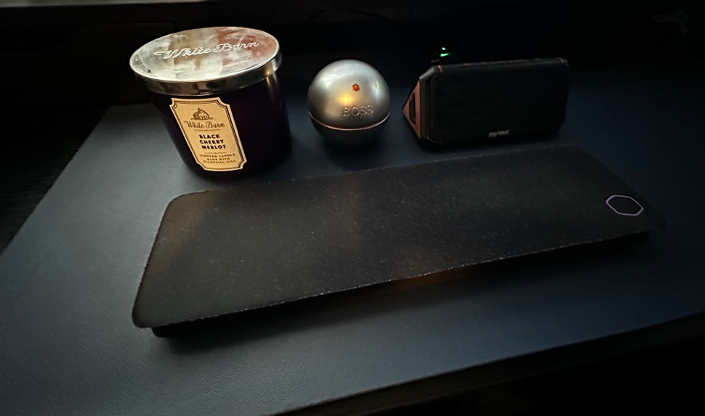

Different Perspective

I will create 3D representations of all these four 2D objects. These are good choices to recreate in 3D because each object can be represented using one or two primitive 3D shapes:

The table and blue mat will be represented by a plane. The scented candle is a cylinder. The circular bottle of cologne is just a sphere, while the keyboard wrist pad is an elongated cube. The speaker can be broken down into two primitive 3D shapes: a pyramid for the 2 corners and a cube will replicate the body of the speaker.